

Semester Two Examination, 2022
Question/Answer booklet

MATHEMATICS
METHODS
UNIT 1&2
Section Two:
Calculator-assumed

Your name

Your Teacher’s name

Number of additional
answer booklets used
(if applicable):

Time allowed for this section

Reading time before commencing work: ten minutes
Working time: one hundred minutes

Materials required/recommended for this section
To be provided by the supervisor
This Question/Answer booklet
Formula sheet (retained from Section One)

To be provided by the candidate
Standard items: pens (blue/black preferred), pencils (including coloured), sharpener,
correction fluid/tape, eraser, ruler, highlighters

Special items: drawing instruments, templates, notes on two unfolded sheets of A4 paper, and up to three calculators, which can include scientific, graphic and Computer Algebra System (CAS) calculators, are permitted in this course examination

Important note to candidates
No other items may be taken into the examination room. It is your responsibility to ensure that you do not have any unauthorised material. If you have any unauthorised material with you, hand it to the supervisor before reading any further.

Structure of this paper

Section | Number of  questions  available | Number of  questions to  be answered | Working  time  (minutes) | Marks  available | Percentage  of  examination
Section One:  Calculator-free | 12 | 12 | 50 | 51 | 35
Section Two:  Calculator-assumed | 13 | 13 | 100 | 100 | 65
 |  |  |  | Total | 100

Instructions to candidates
Markers use only
Question | Maximum | Mark
13 | 8
14 | 8
15 | 6
16 | 5
17 | 5
18 | 11
19 | 8
20 | 9
21 | 8
22 | 8
23 | 10
24 | 9
25 | 5
S2 Total | 100
S2 Wt (×0.65) | 65%

1. The rules for the conduct of examinations are detailed in the school handbook. Sitting this examination implies that you agree to abide by these rules.

2. Write your answers in this Question/Answer booklet preferably using a blue/black pen.
Do not use erasable or gel pens.

3. You must be careful to confine your answers to the specific question asked and to follow any instructions that are specific to a particular question.

4. Show all your working clearly. Your working should be in sufficient detail to allow your answers to be checked readily and for marks to be awarded for reasoning. Incorrect answers given without supporting reasoning cannot be allocated any marks. For any question or part question worth more than two marks, valid working or justification is required to receive full marks. If you repeat any question, ensure that you cancel the answer you do not wish to have marked.

5. It is recommended that you do not use pencil, except in diagrams.

6. Supplementary pages for planning/continuing your answers to questions are provided at the end of this Question/Answer booklet. If you use these pages to continue an answer, indicate at the original answer where the answer is continued, i.e. give the page number.

7. The Formula sheet is not to be handed in with your Question/Answer booklet.
Section Two: Calculator-assumed 65% (100 Marks)
This section has thirteen questions. Answer all questions. Write your answers in the spaces provided.

Working time: 100 minutes.

Question 13 (1.2.9 – 1.2.16) (8 marks)

Given $y=\sqrt{3}-2\sin\left(2x-\frac{π}{3}\right).$

(a) State the amplitude and period. (2 marks)

(b) Find the exact coordinates of all intercepts of $y=\sqrt{3}-2\sin\left(2x-\frac{π}{3}\right)$ with
the axes for $0≤x≤2π$. (3 marks)

(c) Hence sketch the graph of $y=\sqrt{3}-2\sin\left(2x-\frac{π}{3}\right)$ for $0≤x≤2π$,
showing all features from part (a) and (b). (3 marks)

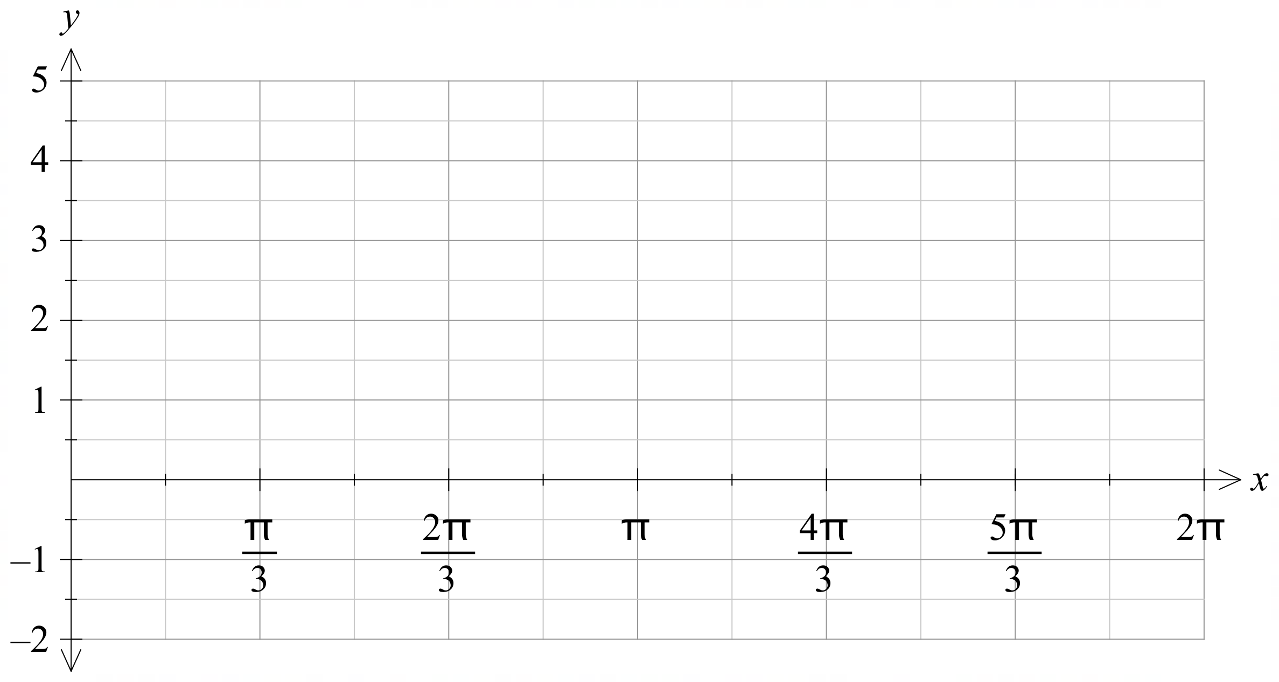

Question 14 (2.3.1 – 2.3.5, 2.3.11 - 2.3.16) (8 marks)

The graph of $y=x^{2}$ is shown below. The graph is a distance-time graph for an athlete running a 100 m sprint. The horizontal axis represents time in seconds, and the vertical axis the distance in metres.

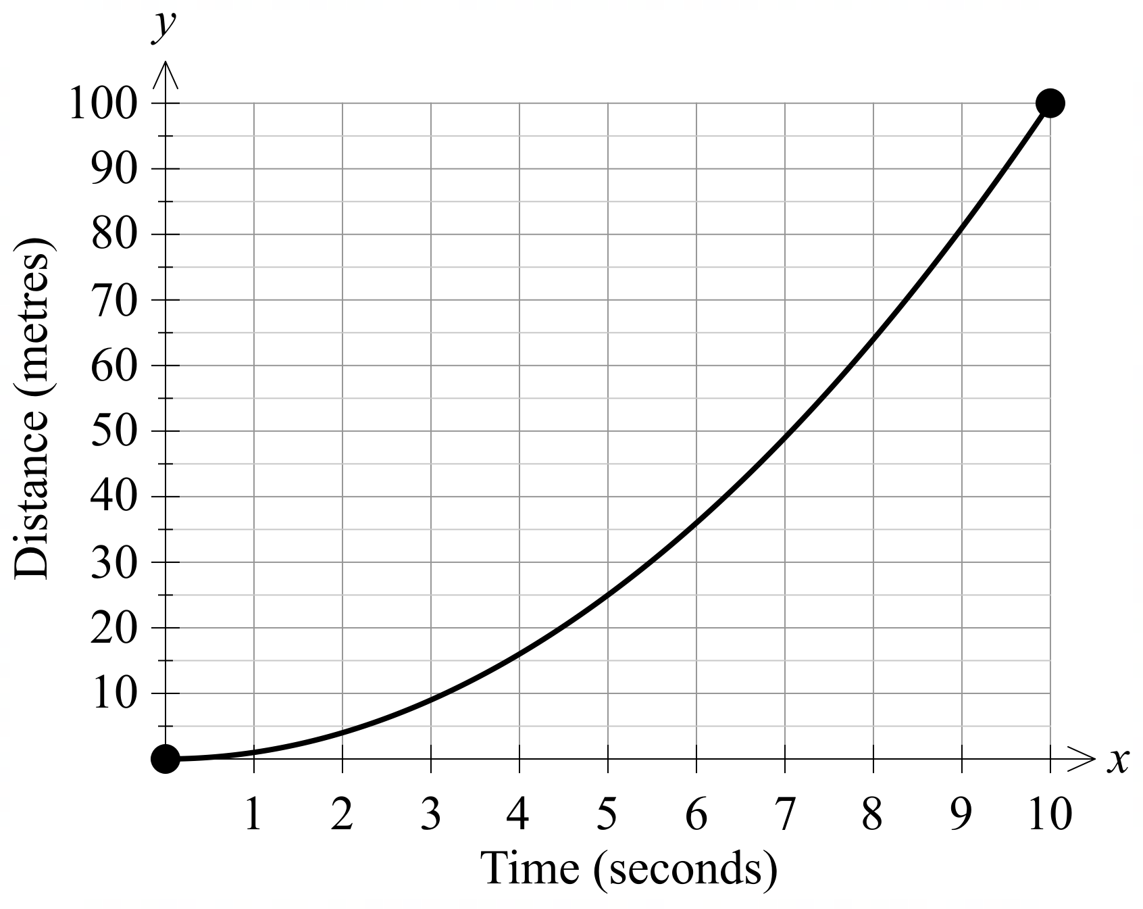

(a) Determine the average speed of the athlete in the last five seconds. (2 marks)

The athlete wants to know their speed at exactly $5$ seconds. To help determine this they determine their distance at a number of other times as shown on the graph below.

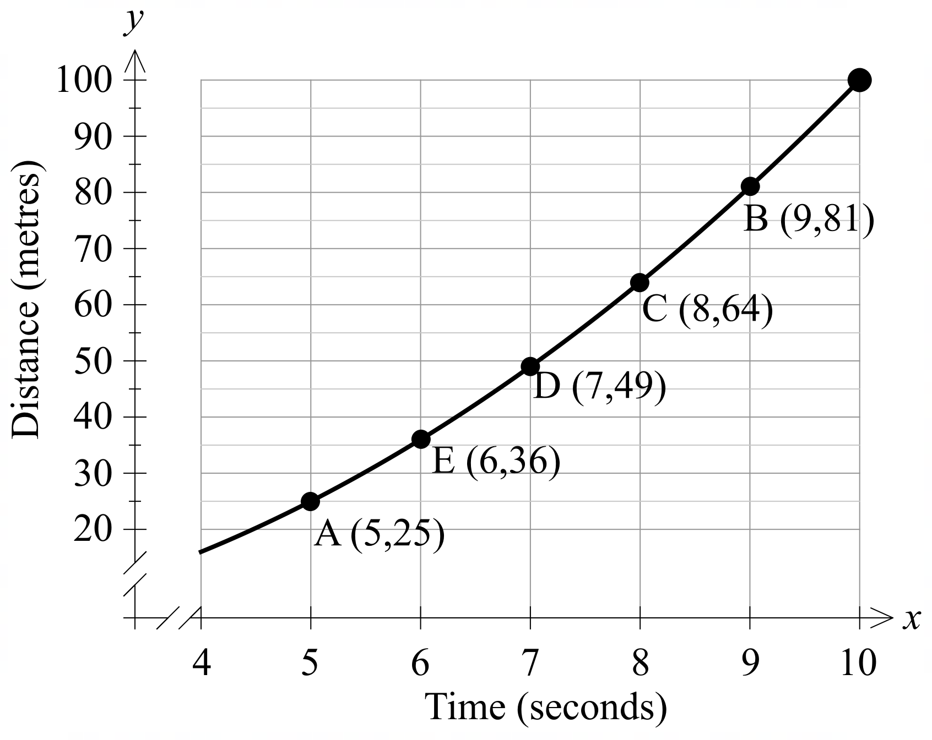

The table below shows the gradients of the chords $AB$ and $AC$.

Chord | $$AB$$ | $$AC$$ | $$AD$$ | $$AE$$
Gradient | $$14$$ | $$13$$ | $$12$$

(b) Complete the table by calculating the gradient of chords $AE$. (1 mark)

(c) Show using first principles that the derivative of $y=x^{2}$ is $y^{'}=2x$. (2 marks)

The gradient of the chords in part (b) can be written as

$$\frac{δy}{δx}≈\frac{f\left(x+h\right)-f(x)}{h}$$

where $δx$ and $δy$ represent changes in the variables $x$ and $y$.

(d) Using parts (b) and (c), determine the gradient of the chord in part (b) as $δx→0$.
Clearly explain how you determined your answer. (2 marks)

(e) Hence state the speed of the athlete at exactly $5$ seconds. (1 mark)

Question 15 (2.3.14, 2.3.18, 2.3.19, 2.3.22) (6 marks)

Particle $A$ starts $2$ m to the right of the origin, and after $t$ seconds has a velocity of $v={3t}^{2}-6t$.

(a) Show that the displacement function is $x=t^{3}-{3t}^{2}+2$ (2 marks)

The displacement, $x$ m, of particle $A$ is shown on the position-time graph below.

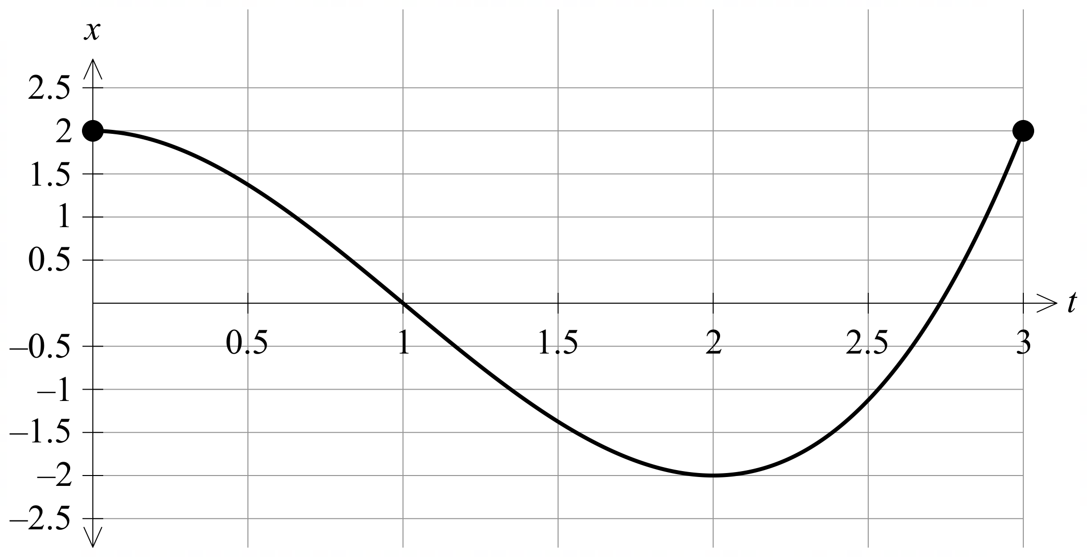

(b) (i) Show algebraically, that particle $A$ starts at rest, and comes to rest
again after 2 seconds. (2 marks)

(ii) Explain how the gradient of the above graph shows that the particle is
travelling to the left for $0<t<2$. (2 marks)

Question 16 (1.3.15, 1.3.16) (5 marks)

A and B are two events where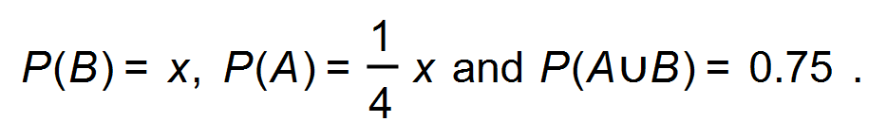
(a) Determine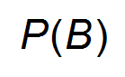so that the events A and B are mutually exclusive.
(2 marks)

(b) Determineso that the events A and B are independent. (3 marks)

Question 17 (2.1.4 – 2.1.7) (5 marks)

The population of a city, Alicetown, increased from 1 358 000 at the beginning of 1990 to 3 246 000 at the end of 2020.

(a) Show clearly that the annual compound growth rate of the population as
a percentage is 2.9%. (3 marks)

(b) If the same annual growth rate of the population is maintained, determine the
population of Alicetown at the beginning of 2050. (2 marks)

Question 18 (1.3.7, 1.3.8, 1.3.10 – 16) (11 marks)

Many websites use multiple authentications to grant access to websites. These methods are classed as:
- something the user knows – passwords, PIN etc.
- something the user has – access to a mobile phone, a bank card etc.
- something the user is – fingerprints, voice recognition etc.

A bank mobile app uses several of these methods. The app first asks the user for their password, and then it will ask them to enter either a code sent to their mobile phone ($M$), or found on the back of their bank card ($B)$. If a user has does not have a strong password, then the website will also require the user to scan their fingerprint ($FP$) or face ($FA$).

(a) Given that a survey by Google found that only $25\%$ of passwords are considered strong ($S$), complete the following tree diagram showing the authentication methods and their associated probabilities. (1 mark)

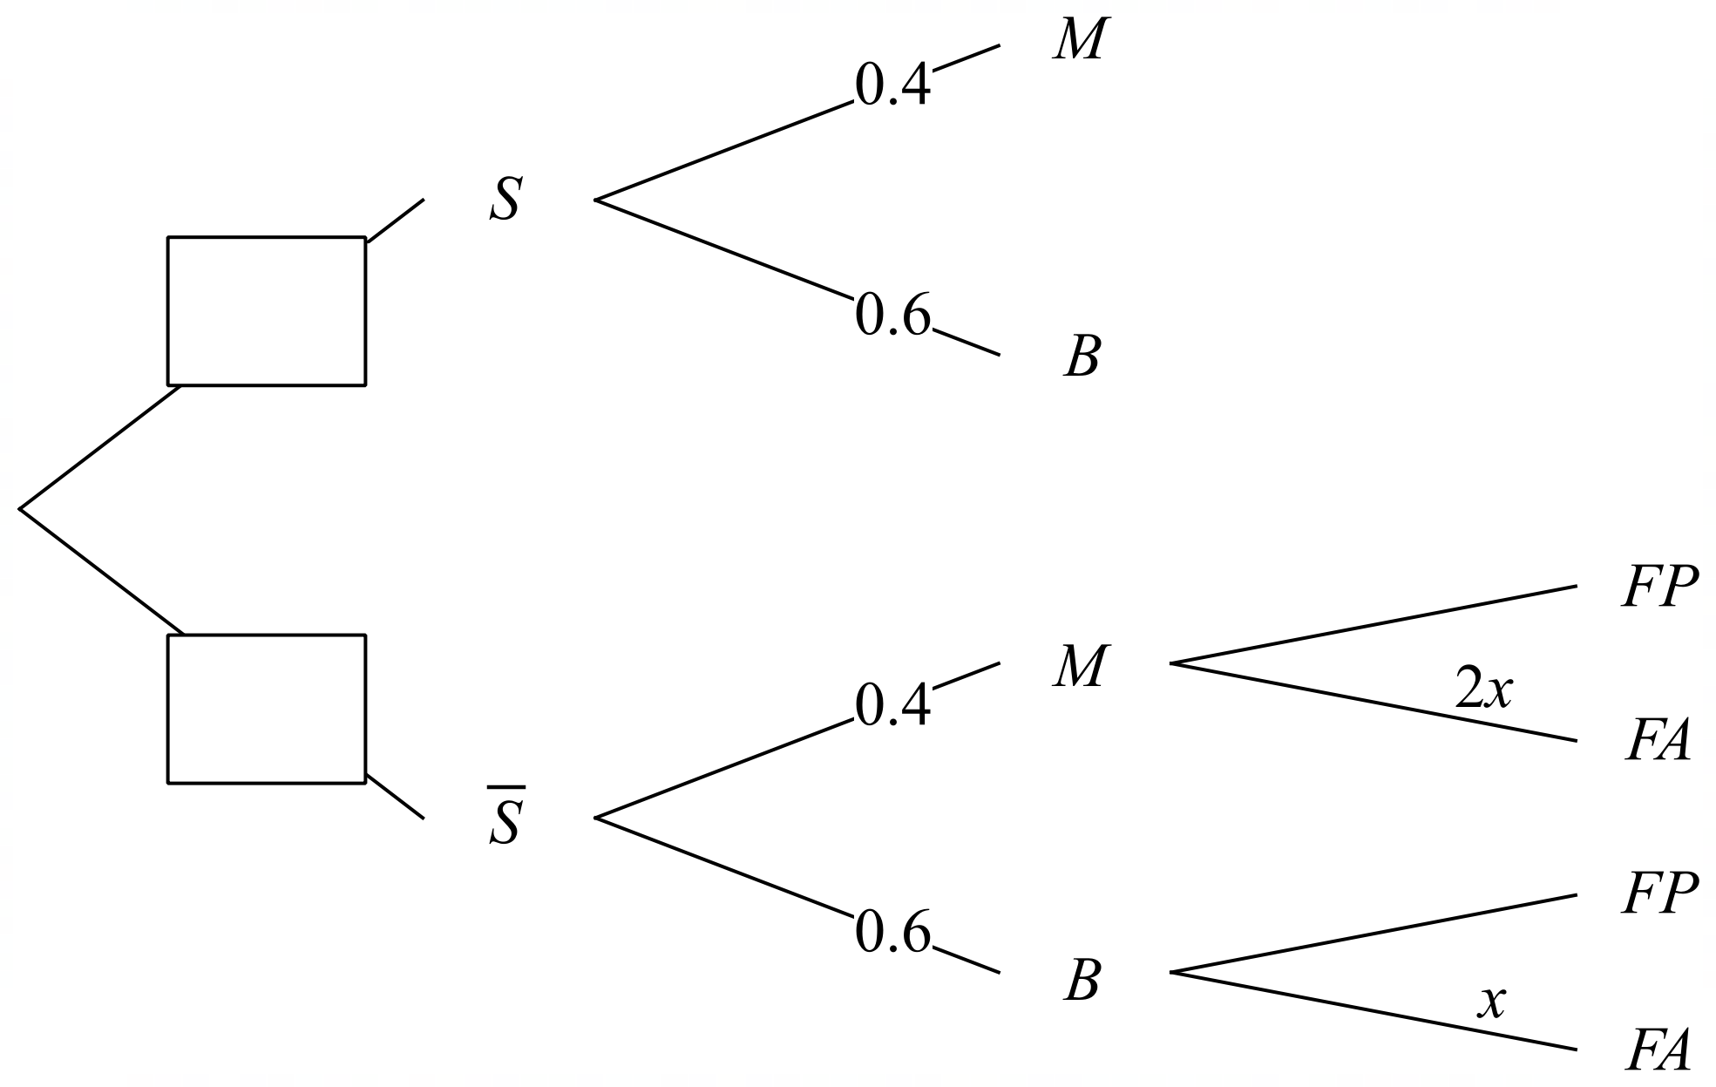

(b) A user’s phone only has a fingerprint scanner. State the value of $x$ in this case. (1 mark)

Out of $200$ randomly selected uses who used the app, it was found that $63$ had to scan their face.

(c) Using this information show that $x=0.3$. (2 marks)

(d) (i) Using the tree diagram, or otherwise, show that the probability the website asks a
user to enter a code sent to their mobile phone is independent of whether their
password is strong or not. (2 marks)

(ii) Hence, explain why events $B$ and $S$ are independent or not. (1 mark)

An analysis of the strong passwords used by users found the following:
- $42\%$ consisted of at least one capital letter ($C$)
- $78\%$ consisted of at least one number ($N$)
- All the strong passwords used contain either capital letter(s) or number(s) or both.

(e) (i) Describe the passwords in the set $C∩N$. (1 mark)

(ii) Determine the percentage of passwords in $C∩N$, and explain why the
two sets are not mutually exclusive. (3 marks)

Question 19 (1.1.14, 1.1.24, 1.1.25) (8 marks)
In an industrial process to create hydrogen, an engineer observed that the higher the power density $P$ W/cm², the shorter the cathode lifetime $T$ in hours, so that when $P=1.4, T=120$ and when $P=2.4, T=75$.
The relationship between the variables is of the form $T=\begin{matrix}a \\ \overline{bP+0.2}\end{matrix}$, where $a$ and $b$ are constants.

(a) Determine the value of $a$ and the value of $b$. (3 marks)

(b) If the process is only possible for $0.4≤P≤3.9$, state the corresponding range of $T$.
(2 marks)

(c) Graph the relationship on the axes below over the domain $0.4≤P≤3.9$. (3 marks)

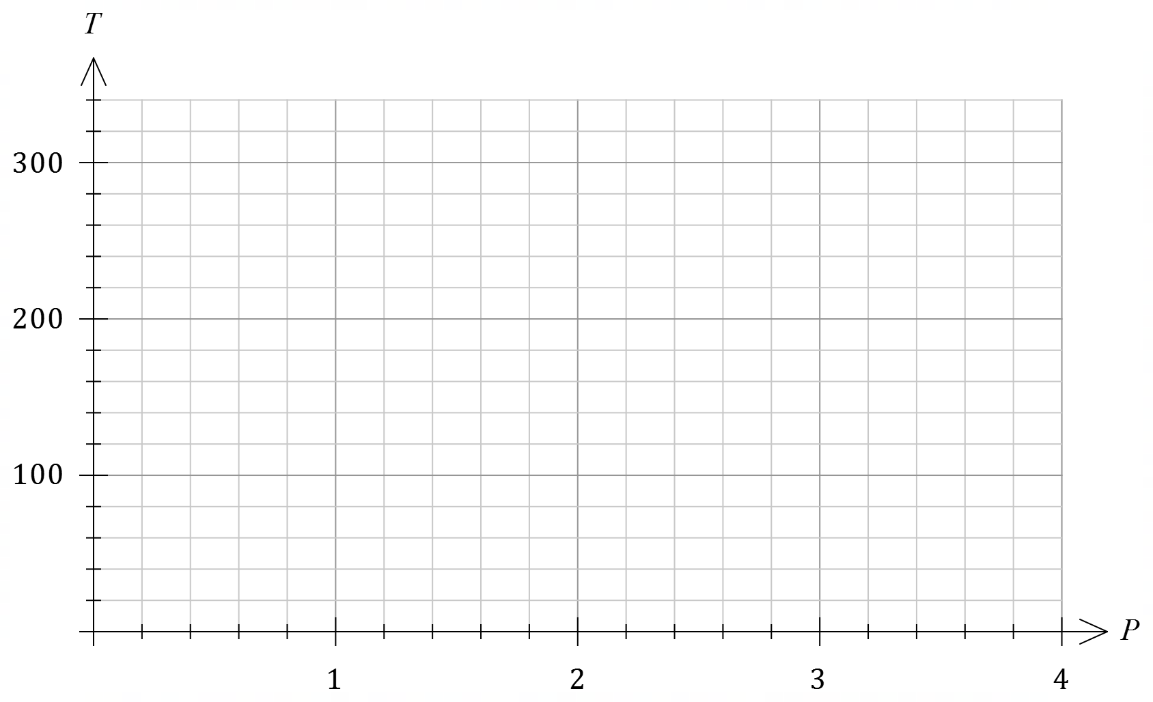

Question 20 (1.3.6 – 1.3.14) (9 marks)

Hospital records for patients presenting with a sports injury classify people aged $18$ or over as adults and the remainder as children. The records show that $65\%$ of these patients are adult, and that after initial treatment, $44\%$ of adults and $36\%$ of children required further treatment.

Determine the probability that a randomly chosen patient presenting with a sports injury

(a) was a child who required further treatment. (2 marks)

(b) required no further treatment. (3 marks)

(c) was a child or required further treatment. (2 marks)

(d) was an adult, given that the patient was known to have required further treatment.
(2 marks)

Question 21 (2.2.1 – 2.2.6) (8 marks)

(a) A large outdoor amphitheatre has $17$ seats in the first row, $20$ in the second row and so on, where each row has three more seats than the previous row. There are $36$ rows of seats in the amphitheatre.

(i) Determine the number of seats in the last row of the amphitheatre. (2 marks)

(ii) Determine the total number of seats in the last $20$ rows of the amphitheatre.
(3 marks)

(b) The sum of the first and second terms of a geometric series is $20$, and the sum of the second and third terms of the series is $60$. Determine the sum of the first three terms of the series. (3 marks)

Question 22 (1.2.4 – 1.2.6) (8 marks)

(a) Express $108°$ as an exact radian measure and hence determine the length of an arc of a circle that subtends an angle of $108°$ at the centre of a circle of radius $15$ cm. (2 marks)

(b) Determine the area of a segment of a circle that subtends an angle of $54°$ at the centre of a circle of radius $46$ cm. (2 marks)

(c) The lengths of the sides of a triangle with an area of $190$ cm² are in the ratio $4:5:8$. Determine the length of the shortest side of the triangle. (4 marks)

Question 23 (1.1.1 – 1.1.6) (10 marks)
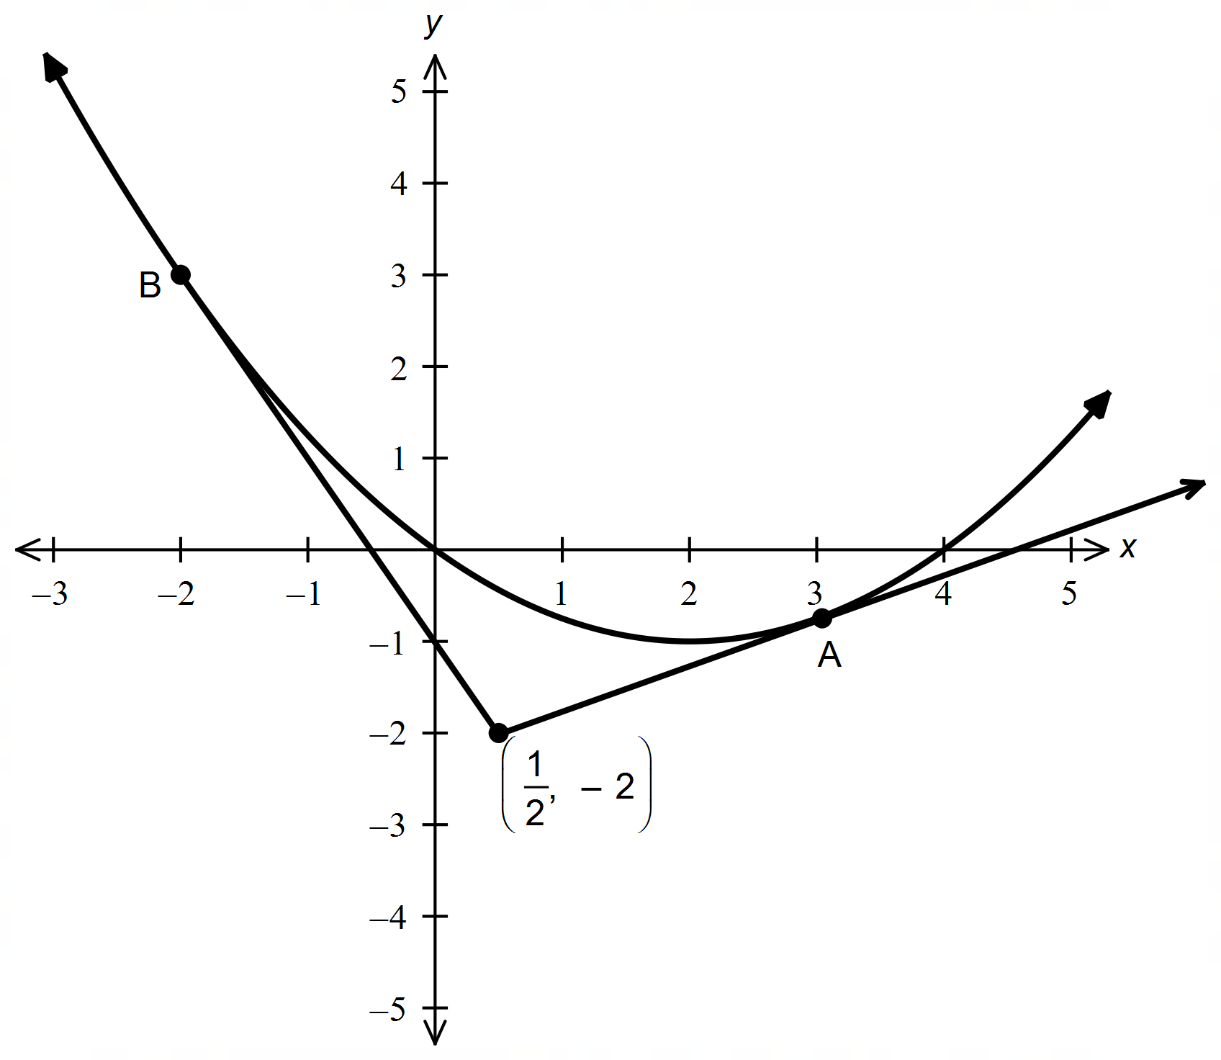Consider the two tangents to the curve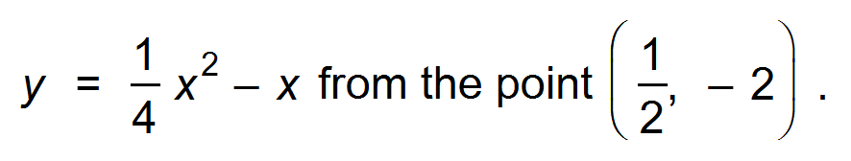

Let the co−ordinates of A be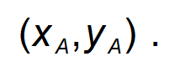

(a) Show that:
(i) 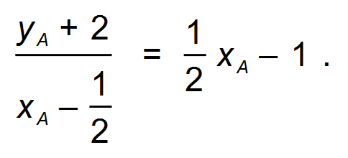 (2 marks)

(ii) and hence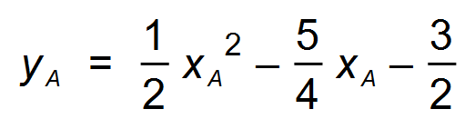. (2 marks)

(b) Use the information in (a) to determine the co−ordinates of A. (3 marks)

(c) Determine the equation of the tangent to the curve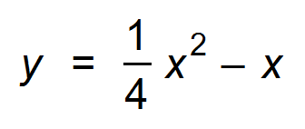which passes through B.
(3 marks)

Question 24 (2.2.1 – 2.2.5) (9 marks)

(a) Consider the following arithmetic sequence: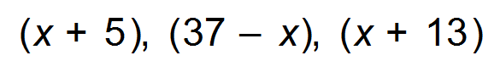.
(i) Determine the value of x. (2 marks)

(ii) State the recursive rule for the sequence. (2 marks)

(iii) Find the 10th term of the sequence. (2 marks)

(b) The sum of the first three terms of a geometric sequence is 91 and its common ratio is 3, determine the third term. (3 marks)

Question 25 (2.2.7 – 2.2.9) (5 marks)

The n-th term of a sequence is given by 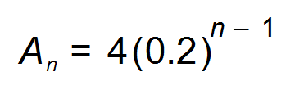.

(a) State the first three terms of the sequence. (1 mark)

(b) Write an expression for the sum of n terms. (1 mark)

(c) Determine the sum to infinity of the series. (1 mark)

(d) Sketch the graph of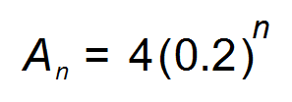on the axes below for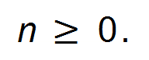 . (2 marks)
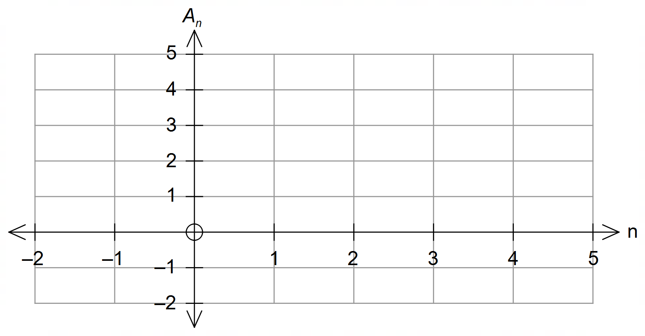

Supplementary page

Question number: _________

Supplementary page

Question number: _________

